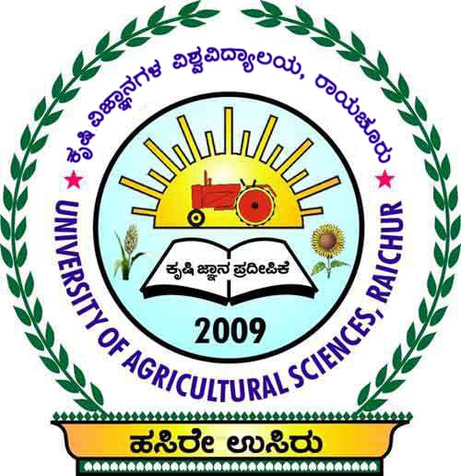



National Workshop
on
Strengthening Seed Production and distribution system for Enhancing Availability of Quality Seeds

Organised by
National Seed Project (Crops), University of Agricultural Sciences, Raichur
in collaboration with
ICAR- Indian Institute of Seed Science, Mau

Venue: Seed Unit, UAS, Raichur Date: February 15-16, 2019
PROGRAMME
Day – I (15.2.2019)
09.00 AM – 10.00 AM | Registration
10.00 AM – 11.00 AM | Inaugural programme  Chief Guests: Dr. Indiresh K.M, Vice Chancellor, UHS, Bagalkot.  Dr. A. Vishnavardhan Reddy, Director, ICAR-IIOR, Hyderabad.  Dr. S.K.Meti, Director of Education, UAS, Raichur.  Dr. B.K.Desai, Director of Research, UAS, Raichur.  Dr. B.M.Chittapur, Director of Extension, UAS, Raichur.  Shri. T.Ramachandraiah, Director, KSSOCA, Bangalore.  Shri. Ananda Krishna, Retd., Managing Director, KSSC, Bangalore.  President : Dr.K.N.Kattimani, Vice Chancellor, UAS, Raichur.  Rapporteurs : Dr. Ajeeth Kumar.K, Scientist (Pl. Path.), MARS, Raichur.  Dr. Shekhargouda S. Patil, Asst. Prof. (Horti), AC, Raichur.
11.00 AM – 11.15 AM | Tea Break
TECHNICAL SESSION - I
11.15 AM – 01.00 PM | Chairman – Dr. Indiresh K.M, Vice Chancellor, UHS, Bagalkot.  Co-chairman – Dr. I.Shankergoud, Dean (PGS), UAS, Raichur  Dr. J.R.Patil, Assoc. Director of Research, ZARS, Kalaburgi  Rapporteurs – Dr. Anupama C, SMS (Home Science), KVK, Raichur.  Dr. Hassan Khan, Scientist (GPB), MARS, Raichur.
11.15 AM – 01.00 PM | LEAD SPEAKERS (20 minutes each)
11.15 AM – 01.00 PM | Dr. Indiresh K.M, Vice Chancellor, UAHS, Bagalkot.  Opportunities in seed production of horticulture crops
11.15 AM – 01.00 PM | Dr.A. Vishnavardhan Reddy, Director, ICAR-IIOR, Hyderabad.  Potentials, Opportunities and Challenges in Quality Seed Production in Oilseeds
11.15 AM – 01.00 PM | Shri. Ananda Krishna, Retd., Managing Director, KSSC, Bangalore.  Policies for strengthening seed production and distribution in Karnataka
11.15 AM – 01.00 PM | Dr.Basave Gowda, Special Officer (Seeds), UAS, Raichur.  Over view of seed industry in Karnataka
11.15 AM – 01.00 PM | Mr.Shripad Amate, Business Development Head,  Save Advanced Solutions Pvt. Ltd., Pune.  Improved storage bags for enhancing seed storability
01.00 PM – 01.45 PM | LUNCH
TECHNICAL SESSION – II
01.45 PM – 04.15 PM | Panel discussion on strengthening seed and distribution system.  Chairman – Shri. Ananda Krishna, Retd., Managing Director,  KSSC, Bangalore  Co-chairman – Dr.B.M.Chittapur, Director of Extension, UAS, Raichur.  Dr.Sathyanarayarao, Associate Director of Research,  MARS, Raichur  Rapporteurs – Dr.Prashanth S.M, Asst. Prof. (SST), KVK, Hagari.  Dr. Umesh Hiremath, Asst. Professor (SST), Seed Unit,  UAS, Raichur.  PANELLISTS (10 minutes each)  - Dr.B.K.Desai, Director of Research, UAS, Raichur.  - Dr.Basave Gowda, Special Officer (Seeds), UAS, Raichur.  - Shri. T.Ramachandraiah, Director, KSSOCA, Bangalore.  - Dr.N.K.Biradar Patil, Prof. & Head & Ex. Director (Seeds), UAS, Dharwad.  - Shri.Shivakumar Swamy, MD, KOF, Raichur.  - Dr.Sudhakar Babu, Nodal Officer (Seeds), IIOR, Hyderabad.  - Dr. M.V. Nagesh Kumar, Director (Seeds), PJTASU, Hyderabad.  - Dr.H.D.Mohan Kumar, Special Officer (Seeds), UAHS, Shivamogga  - Dr.K.Madhu Sudhan, Special Officer (Seeds), UAS, Bangalore.  10. Shri. Bommai, General Manager (Prodn.), KSSC, Bangalore.  11. Sr. Marketing Manager, National Seeds Corporation, Bangalore.  12. Mr. I.L. Patil, President, Karnataka State Certified Seeds Producer  Forum.  13. Mr. M.B.Patil, Proprietor, Krishi Seeds, Koppal.
04.15 PM – 04.30 PM | Tea Break
04.30 PM – 05.30 PM | PLENARY SESSION  Chairman –Dr.K.N.Kattimani, Vice Chancellor, UAS, Raichur.  Co-chairman – Dr.B.K.Desai, Director of Research, UAS, Raichur.  Dr.Basave Gowda, Special Officer (Seeds), UAS,  Raichur  Speakers: Presentation by the respective Chairman of the session.  Rapporteurs – Dr. Jayaprakash Nidgundi, Head, Cotton Scheme, MARS, Rcr  Dr. Rakesh C Mathad, Asst. Prof. (SST), AC, Raichur.

Day – II Field Visit

Visit to NSP (Crops) UAS, Raichur and Commercial Cold Storage (9.00 AM to 5.00 PM)

All are cordially Welcome

Dr.Basave Gowda
Organising Secretary & Special Officer (Seeds)
Scientists & Staff
Seed Unit, UAS, Raichur – 584 104
Ph/Fax:08532 220344, Cell:094806 96343

